Analysis of enabling conditions for [name of city/country]
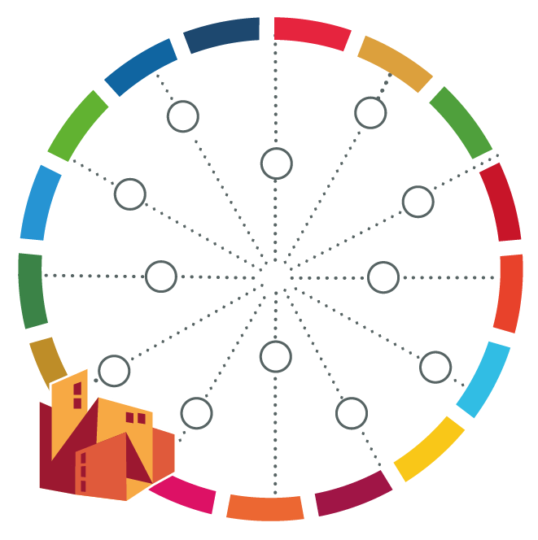
 | Overall assessment of current condition  (poor, satisfactory, good, very good) | Gaps and challenges in your city / country | Options for actions to overcome the gaps/challenges
Constitutional Framework
Legislative Framework
Local Democracy
Financial Transfers from Central to Local Government
Local Governments Own Revenue
Capacity Building of Local Government Administration
Transparency
Citizen Participation
Local Government Performance
Urban Strategy
Environmental and Climate Change Governance
Monitoring and Reporting

What are enabling conditions?
- Decentralized governance: greater resources, capacity development, executive authority, and accountability mechanisms at the local level and metropolitan governance
- Integrated local governance: Vertical coordination between multiple levels of government, inter-departmental or horizontal coordination, inter-municipal or territorial coordination
- Municipal finance: Adequate and solid financial resources at municipal level are key to successful SDG implementation. The fiscal autonomy of local governments, as well as their capacities for financial management need to be strengthened for SDG localisation
- Government capacity development: The scale and breadth of the SDG implementation challenge is immense, and governments at all levels will need to build their institutional capacity to deliver. This section looks at tools and mechanisms to develop local government capacity.
- Policy framework / national urban policy: Policies can enable sustainable urban and local development. Especially national urban policies can support universal SDG achievement across all cities and human settlements in a country. A National Urban Policy (NUP) is a coherent set of decisions derived through a consultative process for a common vision that promotes more transformative, productive, inclusive and resilient urban development in the long term.
- Monitoring and reporting: Measures to monitor and assess the performance of local and regional governments, as well as to support them to improve over time.

