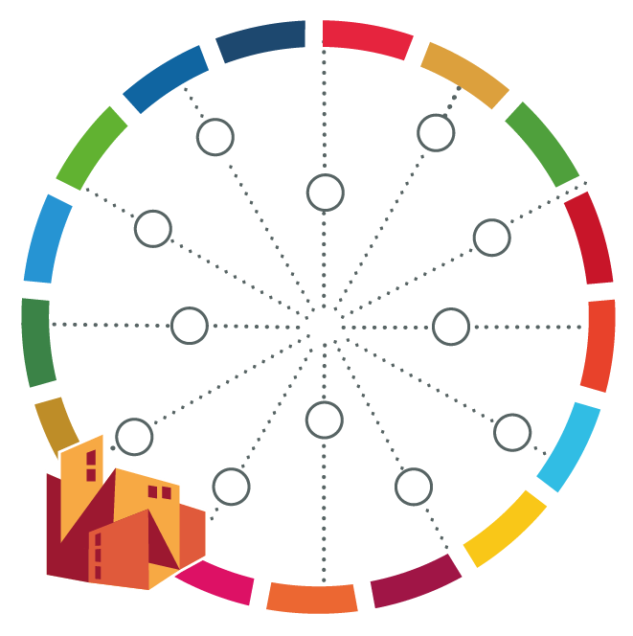
Influence-Interest Matrix

 | Low Influence | High Influence
Low Interest | Least priority stakeholder group | Useful for decision and opinion, formation and brokering
High Interest | Important stakeholder group, perhaps in need of empowerment. | Most critical stakeholder group

