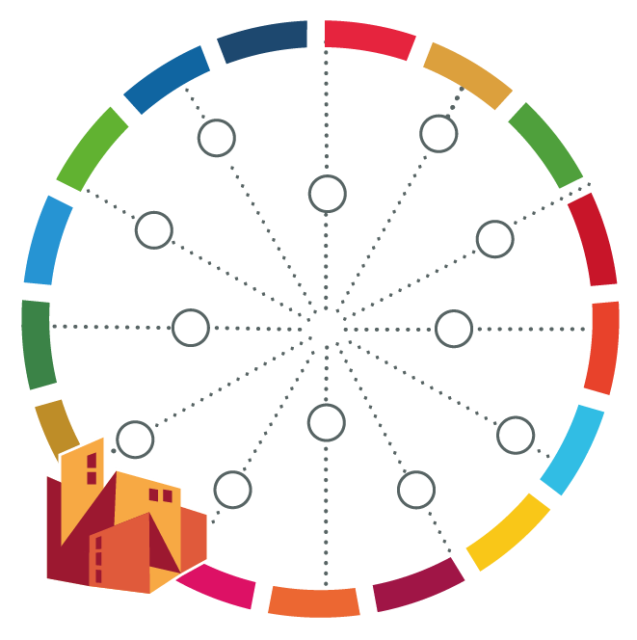
Mandate Check | Step 1

[name of your city]

In order to identify and prioritise areas for action, it is important to assess your city’s mandates and level of control. So, ask yourself: In which of these functions does your city have a high level of control?

Task: Assess the level of control that your city has in regard to the different functions lis ted in the table below (low, medium or high). Critically reflect on formal responsibility on paper versus reality, i.e. ask yourself who has the necessary budget responsibility and/or other resources to implement the function. Then try to list the other governmental and non-governmental actors who may also be responsible for executing the functions (e.g. national or subnational level, private sector, communities) as well as documents in which these mandates and functions are determined.

Function | Level of Control | Further relevant governmental and non-governmental actors | Relevant Documents
Macro-Level Strategies
Development planning
Economic development
Tourism
Major markets
Informal economy
Planning
Regional land use planning
Local land use planning
Land allocation
Land surveying
Titling, provision of tenure
Housing and Facilities
Housing
Social / low income housing
Community upgrading
Cultural facilities
Parks, recreation facilities
Roads and transport
Roads and bridges
Traffic management
Public transit, buses, etc
Street lighting
Street cleaning
Car parking
Security and emergency services
Police protection / security
Fire services
Emergency rescue services
Ambulance services
Water and sewerage
Water supply system
Drainage / flood protection
Piped sewarage system
Solid waste collection
Solid waste disposal
Social services
Education, primary and secondary
Health care
Welfare assistance
Childcare services
Energy
Electricity supply
Gas supply
Miscellaneous
Libraries
Business licensing
Local agriculture
Environment/ natural resources protection

