Global Agendas Questionnaire

City/Country:
Position:
Affiliated institution/organisation:
Email (voluntary):
Mobile Number (voluntary):

Please try to answer the following questions as honest as possible. The results will be used to identify current needs and knowledge about global agendas in your city. They will not be shared with third parties nor used for different reasons.

1. Are you familiar with and/or involved in the implementation of the SDGs (2030 Agenda)?
☐ I am not familiar with the SDGs
☐ I know the SDGs exist, but am unfamiliar with their details
☐ I use the SDGs as a reference, but they are not high in our work priorities
☐ I align my work priorities with the SDGs

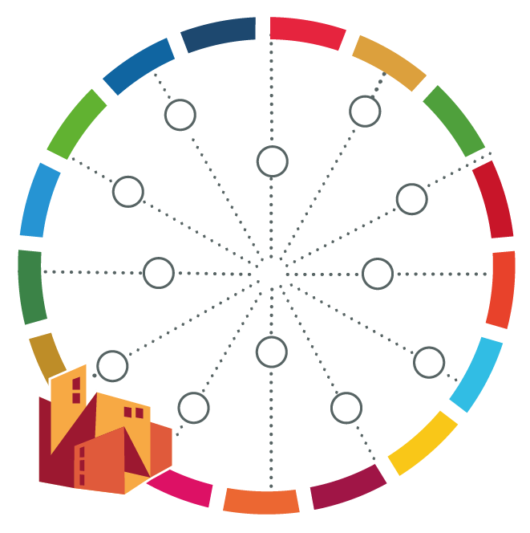
2. Are you familiar with and/or involved in the implementation of the other global agendas (i.e. New Urban Agenda, Paris Climate Agreement, Sendai Framework, Global Compact for Migration) and/or regional agendas (i.e. African Union’s Agenda 2063)?
☐ I am not familiar with any of the other global and regional agendas
☐ I know they exist, but am not sure how they relate to my work
☐ I refer to some of these Agendas in my political work as a reference
☐ I have integrated the Agendas in my advocacy and daily work

3. How familiar with and/or involved in the implementation of the SDGs would you say your city administration/institution is?
☐ Very few individuals in the city/institution are familiar with the SDGs
☐ Many have heard about the SDGs, but are not aware about their relevance
☐ The majority of our staff is aware and makes reference to the SDGs, but it is not high in our work priorities
☐ The SDGs are well known in our institution and used as an important reference in our strategies

4. What do you think are the main challenges that local and regional governments face in working towards the achievement of the SDGs and other global agendas?
Please select no more than 5 options and rank them by relevance from 1 (most important) to 5 (least important):
☐ Limited access to information
☐ Limited support from national governments
☐ Limited coordination across levels of governments
☐ Limited local interest and/or awareness (e.g. local governments don’t understand the SDGs, don’t find them relevant or perceive them as a new burden, not adapted to local priorities)
☐ Inadequate human resources or weak capacities
☐ Insufficient financial resources
☐ Need for legal and institutional reforms to empower local and regional governments

5. What topics do you think are most relevant for your city?
Please select no more than 5 options and rank them by relevance from 1 (most important) to 5 (least important):
☐ Economic growth
☐ Up-grading informal settlements
☐ Environmental protection
☐ Gender equality
☐ Quality and affordable infrastructure
☐ Quality education
☐ Employment generation
☐ Quality health services
☐ Sustainable tourism
☐ Sustainable consumption and production
☐ Other: ________________________________________________________

6. What learning benefit would you most want to gain from attending learning/capacity building activities on SDGs and/or other global agendas?
Please select no more than 3 options and rank them by relevance from 1 (most important) to 3 (least important):
☐ Knowledge about the issue and its relevance to my work
☐ Network on SDG issues
☐ Experience sharing on real and practical actions to implement and achieve SDGs
☐ Contact for donors and development of plausible future projects
☐ Traveling overseas
☐ Others: _____________________________________________________________

7. What topic do you want to learn the most to understand the SDGs?
Please select no more than 3 options and rank them by relevance from 1 (most important) to 3 (least important):
☐ More detail general knowledge on SDG
☐ Specific topic related to other governorates/local governments action on SDG
☐ Developing evidence base information for policy input and decision making on SDG
☐ The relevance between SDG and governorates/local governments roles SDG
☐ Policy implementation of SDG
☐ Monitoring the SDG
☐ Best practices compilation from other governorates/local governments on SDG
☐ Other: _____________________________________________________________

8. What learning format do you think is most suitable to learn about the SDGs
Please select no more than 3 options and rank them by relevance from 1 (most important) to 3 (least important):
☐ Class lecture
☐ Role play and other modern format of learning
☐ Seminar and technical workshop
☐ Peer learning visit
☐ Action plan development on specific topic of SDG
☐ Other: ______________________________________________________________

9. Any other comments/expectations
__________________________________________________________________________
__________________________________________________________________________
__________________________________________________________________________
__________________________________________________________________________
__________________________________________________________________________

