Rapid Assessment of Long-Term Vision – Disaster Risk Reduction (DRR) & Resilience perspectives

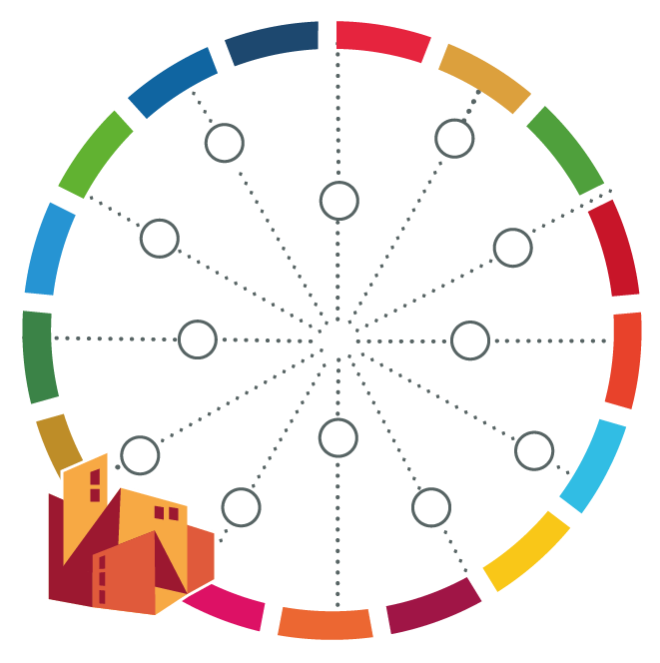
[name of your city]

DDR Perspective
Hazards | Vulnerabilities
Resilience Perspective
Shocks | Stresses

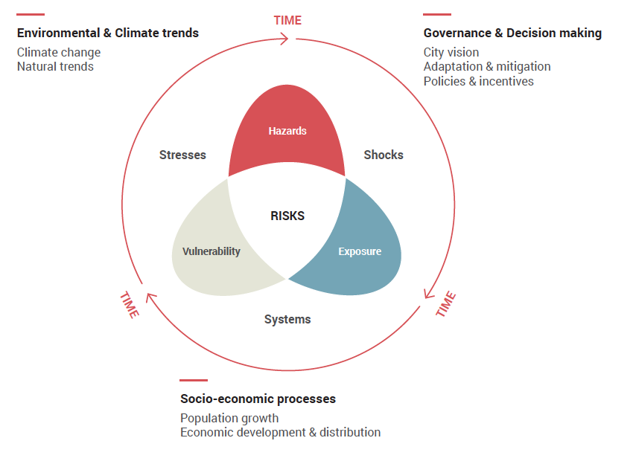
Fig 1. A more systemic understanding of risk and resilience includes different types of shocks, stresses, and considers the effect of environmental, socio-economic and political processes and trends. Source: Developed by UCLG Learning in Fundamentals of Resilient Governance & Development: Resilience Learning Module I.

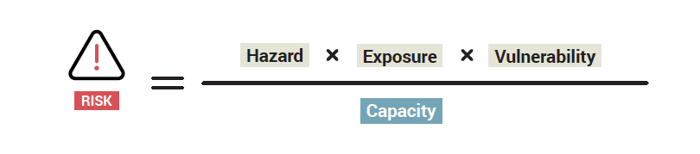
Fig 2. Risk is a combination of an existing hazard with exposure, vulnerability, and the capacity to confront it or overcome it. Source: Fundamentals of Resilient Governance & Development: Resilience Learning Module I.

Definitions:
Disaster risk is defined as “the potential loss of life, injury, or destroyed or damaged assets which could occur to a system, society or a community in a specific period of time”. In simplistic terms, disaster risk is determined as a function of hazard, exposure, and vulnerability.
Exposure is situation of people, infrastructure, housing, production capacities and other tangible human assets located in hazard-prone areas. E.g. a neighbourhood is usually affected by flooding events; a region is commonly used by refugees crossing to another country.
Hazard is a process, phenomenon or human activity that may cause loss of life, injury or other health impacts, property damage, social and economic disruption or environmental degradation. E.g. earthquake, flood, epidemic, storm, heat wave, landslide, volcanic eruption.
Vulnerabilities are the conditions determined by physical, social, economic and environmental factors or processes which increase the susceptibility of an individual, a community, assets or systems to the impacts of hazards. E.g. poverty, lack of infrastructure, age/gender, subsistence economy.
A Resilient City is the one able to absorb, adapt, and recover from the shocks and stresses that are likely to happen, transforming itself in a positive way toward sustainability.
Shocks are sudden onset events, leading, potentially, to adverse impacts unfolded within hours or days in the urban areas. E.g. disease outbreaks, weather-related and geophysical events (flooding, earthquakes), outbreaks of violence, or economic crisis.
Stresses are defined as chronic pressures whose cumulative impacts undermine city’s capacity for resilience. E.g. natural resources degradation, climate change, political instability or economic recession.

Sources:
UN-HABITAT. 2018. City Resilience Profiling Tool (CRPT).
UCLG 2020. Fundamentals of Resilient Governance & Development: Resilience Learning Module I.
UNISDR. 2017. Handbook for Local Government Leaders: How to Make Cities More Resilient.

