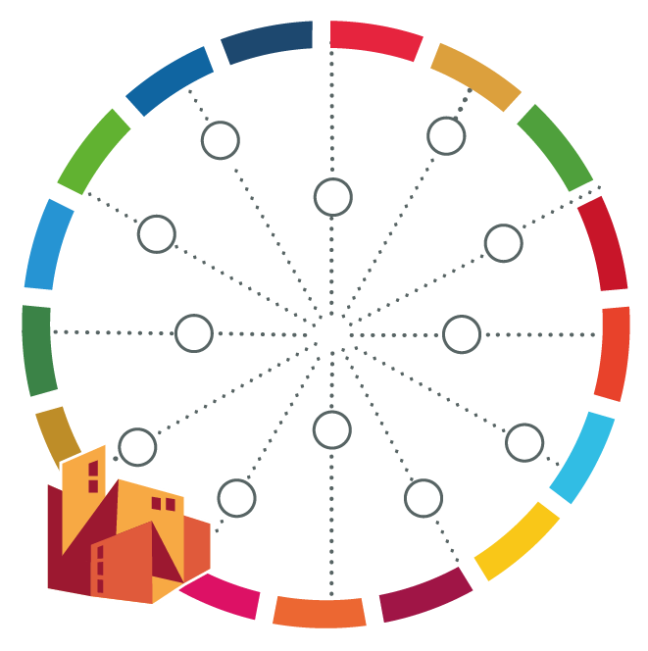**Stakeholder Mapping**

**Stake Diagram**

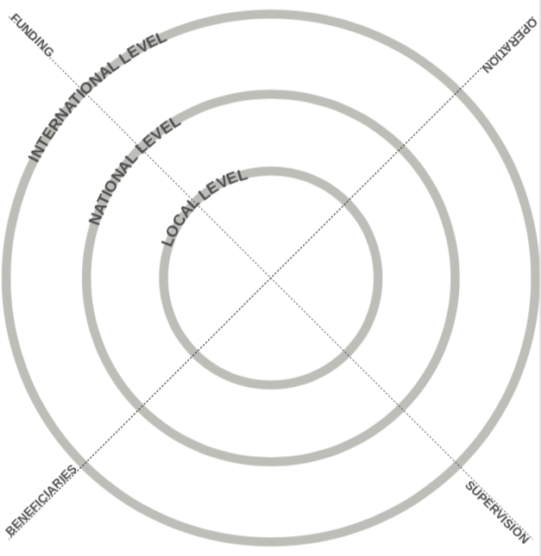

**Stakeholder Mapping**

**Influence-Interest Matrix**

