Exploring future scenarios

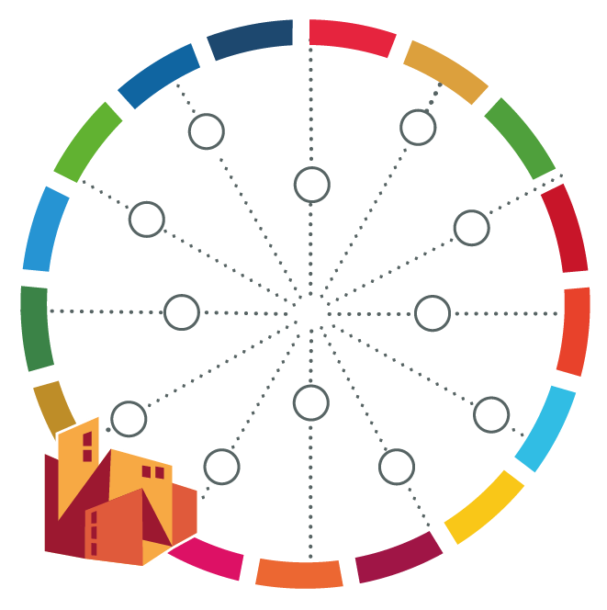
[name of your city]

You have identified various challenges and opportunities your city faces today. Now it is time to understand how the future scenarios can influence them, positively and negatively.

Aspect | Potential scenario | Likelihood and consequence (see table below) | Impact of future scenario in identified challenges and opportunities | New challenges and opportunities
Society: population trends, migration patterns, expected COVID-19 impact
Technology: new available technologies, new applications
Environment: climate change, vulnerabilities, changes in ecosystems
Economy: changes in economic sectors, reliance on certain products/imports
Politics: stability, elections, conflicts

Table for ranking likelihood and consequence
 | Likelihood | Consequence (on aspects associated with city resilience)
High | Expected to occur (> 70% probability) | Significant impact (e.g. irreversible or widespread shock in service, infrastructure or politics)
Medium | Could occur (around 50% probability) | Moderate impact (e.g. temporary loss of service, infrastructure or political stability)
Low | Unlikely but could potentially occur (< 30% probability) | Minor impact (e.g. localized or minor service disruption)

Within the timeframe of the work you are doing (e.g. a Strategic Plan 2030)

