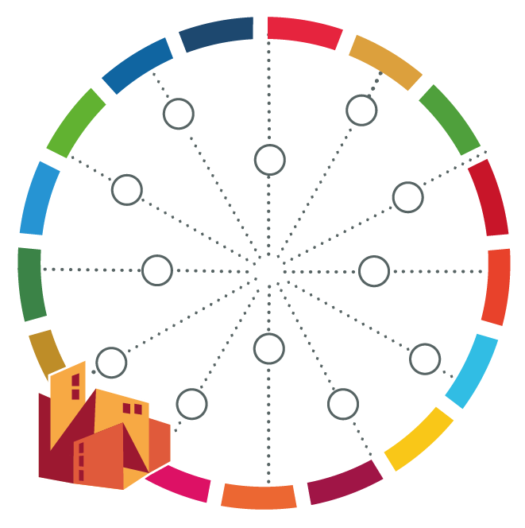
Operational Plan for City WORKS Application

Activity | Responsible person | Deadline | Resources available/ needed | Documents available/  needed | Persons/Stakeholders to be involved

