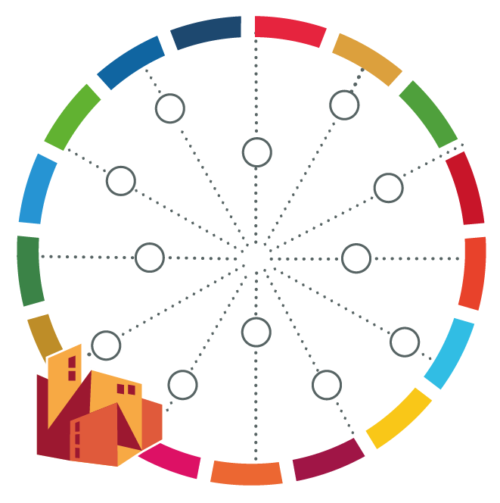
Selected City WORKS Tools

City WORKS Step | City WORKS Tool | Possible setting | Timeframe | Partners to be involved | Comments

