Assessing Project Bankability

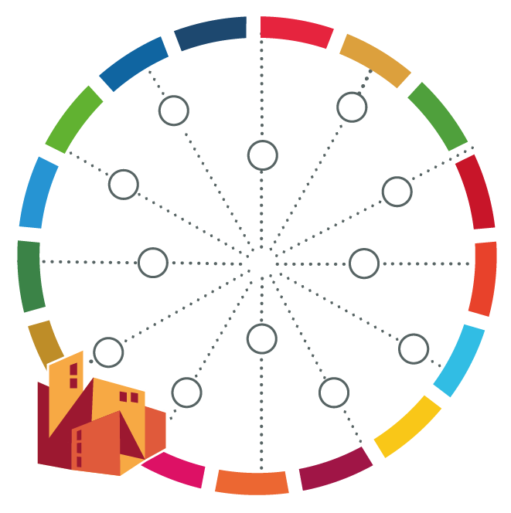
[name of your city]

After you have assessed the potential impact and feasibility of your project, it is time to check if it embraces the main elements that are necessary for it to be financed by the usual financing institutions. Please confirm if the proposed project contains all elements below, and provide comments on how it has been covered or how it can be covered if not yet. Use one sheet per project.

Please note that this is just a preliminary screening for project bankability, and by no means it means the project will be automatically accepted for funding by institutions.

Aspect | Source of information | (Project Name) – Yes/No + comments
Ownership model  The governance structure (who will lead, what institutions will participate) is well defined | City WORKS “Action Plan” and “Mandate Check” tools
Project framework  Goals and objectives are well defined  The project is aligned with global agendas | City WORKS “Impact Check” and “Detailed Project Preparation and Exchange” tools
Political commitment  Project is included in local and national priorities (strategic or sectoral plans), communicated to the public | Local and national frameworks, public announcements, letters of endorsement – City WORKS “Review Local Plans and Policies” tool
Ambition of resilience/climate impact  Qualitative and quantitative project impact is measured (e.g. reduction on CO2 emissions) | Project feasibility study
Maturity  Project stage: scoping, pre-feasibility, feasibility | Feasibility studies
Economic, technical and financial viability  Project considers elements that might render it not feasible for implementation or do not reach significant positive social, economic and environmental impact | City WORKS “Feasibility Check” tool
Innovation, replicability and scalability
Project can be replicated in another area within the same city, other city in the same country, or cities in different countries; if it can be expanded; in its entirety or partially
Social and other co-benefits
Project will have positive impacts on
(a) social inclusion and vulnerable groups
(b) gender
(c) livelihoods/local economic empowerment

