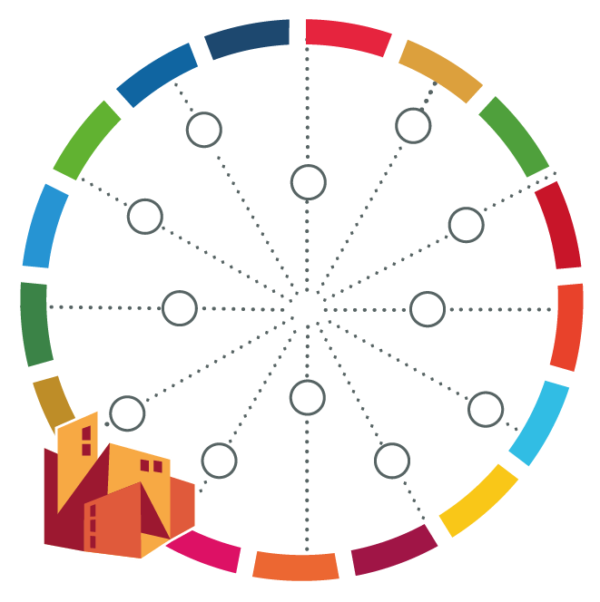
Brainstorming Challenges and Potentials for Urban Action

[name of your city]

Prioritised Issue -Challenge/Opportunity | Link to 2030 Agenda  SDG goals/principles | Link to Mitigation of Green House Gases (yes/no) | Link to Adaptation to the Effects of Climate Change (yes/no) | Link to New Urban Agenda/National Urban Policy | Link to Disaster Risk Management

