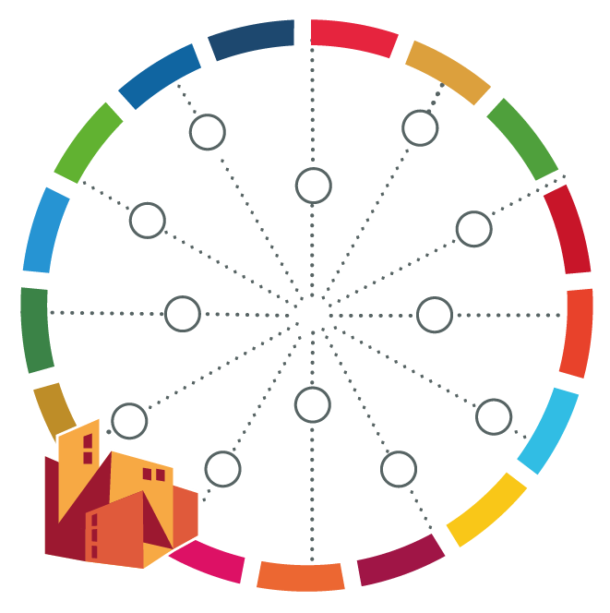
City Profile for [name of your city]

Type of information | Data/Value | Source of Data | Year of Data
Total city population (registered / estimated)
City area (square kilometres)
Population density (per square kilometre)
Population that are youth (15-24) (%)
Population that are senior citizens (65+) (%)
Gender (female-headed households)
Literacy rate (% literate population)
Poverty rate (% population not in poverty)
Unemployment rate (% population not working)
Average household income
Residents who do not have the national citizenship (%)
Residents living in informality (%)
Total number of households
Persons per unit
City product per capita
Main economic sectors
Total revenue collection
Urban land use
Geographic location / climatic conditions
Human Development Index
Role of municipality in regional context
Planning / strategic documents available

