Reviewing Local Plans & Policies Against Several Global Agendas

Current Plan/ Action/Project | Positive contribution to SDGs | Negative contribution to SDGs | Contribution to NUA | Contribution to Climate Change Mitigation | Contribution to Climate Change Adaptation | Contribution to Disaster Risk Reduction
 |  |  |  |  |  | 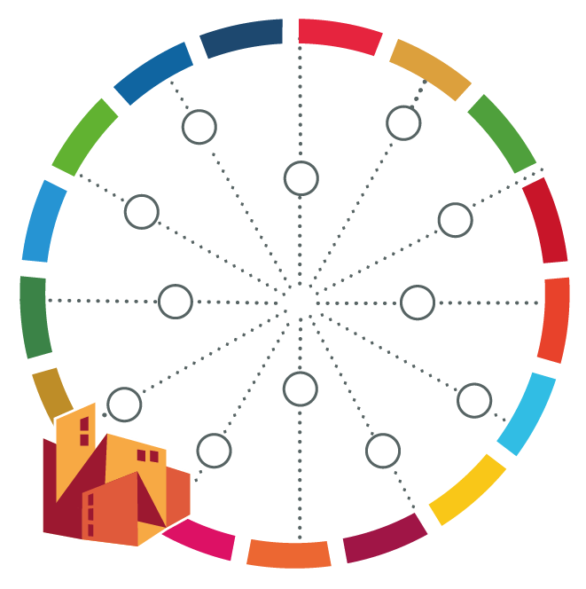
[name of your city]

