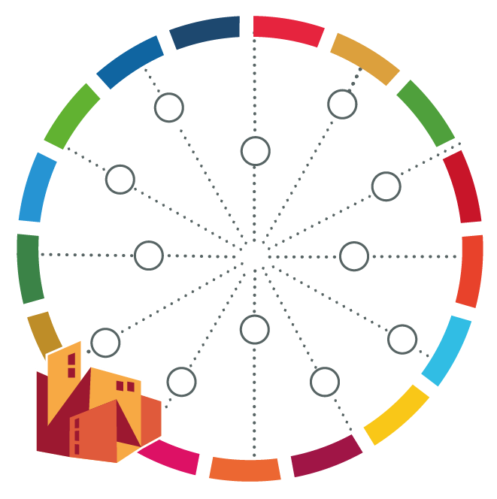
Self-Assessing Relevant Global Targets – Deeper Analysis

[name of your city]

Categories assessed as bad/ critical | Possible reasons for this | Ideas for improvement | Possible indicator for tracking progress (optional)

