Impact Check

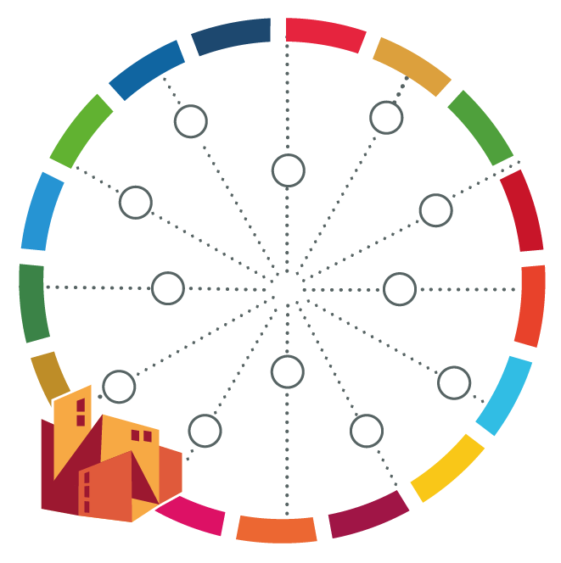
[name of your city]

You have identified various potential measures to foster the sustainable transformation of your city. To understand the impacts these measures may have in relation to global agendas think about the following questions and note down the findings in the table below:
- Does the measure or action contribute positively to the achievement of the SDGs? If so, to which one(s)?
- Does it contribute negatively? If so, to which SDGs?
- Can the measure be adapted/improved in light of the implementation principles of the 2030 Agenda, i.e. leave no one behind, shared responsibilities, accountability, integrated approach, and universality? If so, how?
- Does the measure have a strongly positive / positive / neutral / negative / strongly negative contribution to the mitigation of climate change?
- Does the measure have a strongly positive / positive / neutral / negative / strongly negative contribution to the adaptation to climate change?
- Does the measure have a strongly positive / positive / neutral / negative / strongly negative contribution to the disaster risk reduction?
- Does the measure contribute to the commitments of the New Urban Agenda? If so, to which one(s)?

Potential measure / project | Contribution to 2030 Agenda |  |  | Contribution to New Urban Agenda | Contribution to Climate Change Mitigation | Contribution to Climate Change adaptation | Contribution to Disaster Risk Reduction
 | Positive contribution to SDGs | Negative contribution to SDGs | Impact on implementation principles (LNOB, shared responsibilities, accountability, integrated approach, universality)

