**Mandate Check | Step 2 (Influence Matrix)**

**[name of your city]**

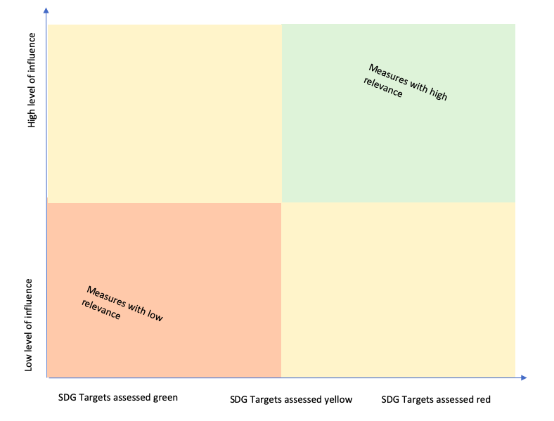

**SDG targets assessed good/very good**

**SDG targets assessed basic**

**SDG targets assessed critical**

