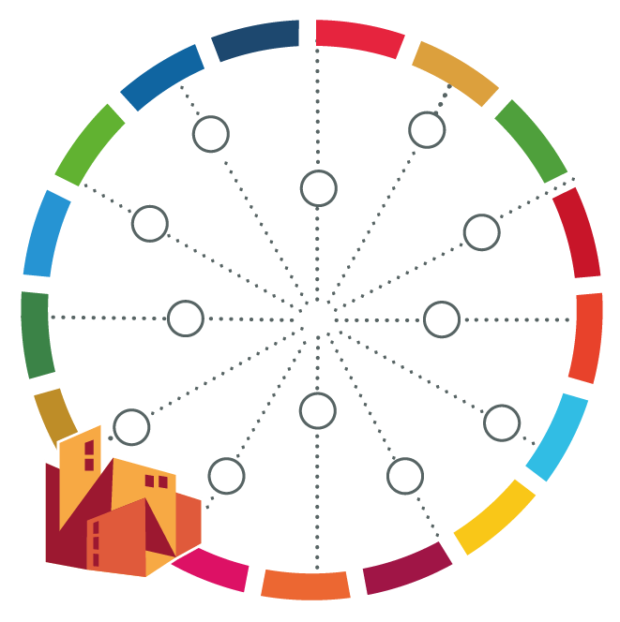
Road Map for Implementing [Measure]

[name of your city]

Steps | Activity | Responsible Person/Department | Timeframe
Raising awareness / Stimulating local commitment
Baseline Study / Understanding current situation in the city
Stakeholder mapping and identifying formats for engagement
Creating a task force on global agendas
Developing an action plan
Synchronising activities with national agendas and strategies
Setting up a business model (financial resources)
Monitoring and evaluating progress
Capacity development and best practice promotion

